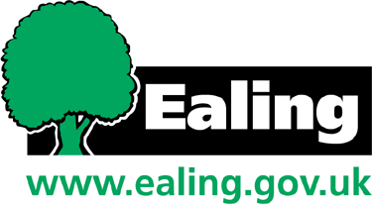
Ealing Council

David Cameron MP  Prime Minister  10 Downing Street  London  SW1A 2AA | Liberal Democrat Group Ealing Council  Room 4.01  Town Hall  New Broadway  London  W5 2BY
Dear Prime Minister,

I write with sadness at what I can only describe to you as an example of a Conservative Party Councillor in Ealing, who has made a statement which residents are accusing him as being racist.

I wish you to, first of all, be aware of the case so you can take action to ensure the individual is not able to use words which have offended many residents in Southall. I understand you have the power to expel him. I ask that you do that and do that now.

All elected Councillors and Members of Parliament have a duty to bring our communities together so we can improve where we live. The author of the blog, Councillor Benjamin Dennehy, has offended a large number of Ealing residents. You will see I have also enclosed a copy of the blog-post so you can see the many examples where Indians or those from Southall have been verbally abused.

I list a couple of the comments made, so you can quickly grasp what I am talking about:

- Councillor Benjamin Dennehy links a "second-rate nation" directly to immigration. One resident stated in a letter to me that this is racist.
- Later Benjamin Dennehy linked immigration as a direct cause of the "nation’s fabric" being "destroyed". Again a reader said this was both emotive and racist.
- He linked problems such as gambling, prostitution and drugs, with the Indian community. One senior member of the community said the comment was both racist and ignorant.
- Later he used "illegal immigrants", when in earlier paragraphs he talked of "immigrants" - does he not know the difference? Again, he has shown his ignorance.

Each time the blog-post was read by myself or others, new elements smacking of racism reared its head. I ask that you, in your role of Leader of your party, take action to stop this behaviour from ever happening again as well as sending a signal to others that racism and causing offence is not acceptable in our country.

Yours sincerely


Councillor Gary Malcolm
Leader, Liberal Democrat Group

