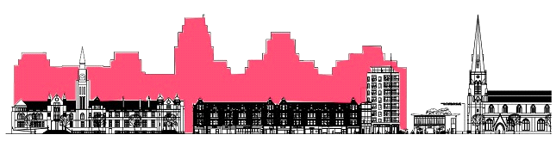
Save Ealing’s Centre presents a public meeting:

EALING CENTRE IN CRISIS?
Monday 22nd February at 7.30pm
Victoria Hall, Ealing Town Hall

Chair: Stephen Sackur of the BBC

Your chance to question the candidates who want your vote ...

... as MP for the new Ealing Central and Acton constituency:
- Jon BALL (Lib Dem)
- Angie BRAY (Con)
- Bassam MAHFOUZ (Lab)
… as Councillors for main parties in the London Borough of Ealing:
- Julian BELL* (Lab)
- David MILLICAN (Con)
- Harvey ROSE (Lib Dem)

(* invited)

- How can we get an Ealing Broadway TRANSPORT INTERCHANGE?
- How many NEW HOMES can fit in Ealing Town Centre?
- Where will new facilities for SCHOOLS, HEALTH and POLICING be built?
- ARCADIA is rejected. DICKENS YARD may be under legal review. What next?
- How can the SHOPPING change for the better?
- What about other attractions – ARTS, CULTURE, LEISURE and SPORT?
- How can THE COMMUNITY ENSURE THAT ITS VOICE IS HEARD?

ALL WELCOME!

For more information and to see our Vision document, visit: www.saveealingscentre.com

